User Guide
Shipping Raw Steel and Steel parts to LEGO in Mexico

Table of content
Table of content 1
1. User Guide Coverage 2
1.1 Purpose 2
1.2 Scope 2
2. Terms and Abbreviations 2
3. Importing Steel Parts – Context 2
3.1 Information required (check list) 3
3.2 Documents for the AAIPS 3
4. Tips & Tricks 3
5. References 4
Appendix 5
A. Example of MTC/MTR 5
B. Example of Complimentary Declaration 6

User Guide Coverage

Purpose
The purpose of this user guide is to set the information needed for customs clearance when shipping raw steel and steel parts to LEGO in Mexico.

Scope
The scope of this user guide is limited to raw steel and steel parts shipped to LEGO in Mexico that can be covered in one of the following descriptions (example):
- Raw steel
- Spare parts made of steel, for example cables, tubes, profiles, bars, etc.
- Pipes with and without seam, roll plates, cold and hot rolled sheets, slabs, steel bars, wire rods, profiles, and all steel parts without any previous work.

This user guide applies for shipments to LEGO Group entities in Mexico.

Terms and Abbreviations
AAIPS: Notification of Importing Steel products (AAIPS in Spanish language), regulated by the Mexican Ministry of Economy.
DOF: Official Newsletter of Mexican Government
HS Code: Harmonized System Codes
Mill Test Certificate (MTC) or Mill Test Report (MTR): Statement of compliance with the order and international standards, with indication of results of quality inspection and chemical and mechanical properties of the steel met.

Importing Steel Parts – Context
According to the Mexican regulation “ACUERDO que modifica al diverso por el que la Secretaría de Economía emite reglas y criterios de carácter general en materia de Comercio Exterior” published in December 15th 2013 in the DOF, some HS Codes have a mandatory requirement to present the AAIPS in the Mexican Ministry of Economy before the importation of the goods.

This regulation affects us directly, due to its last modification in September 29th of 2015 when some other HS Codes were included. These added HS Codes refers to the most common presentation of steel products and spare parts made of steel. To check HS code in scope, please see Appendix A.

The present User Guide has two sections:
- Information required (check list)
- Documents for the AAIPS.

Information required (check list).
The following is the information we need to know in order to proceed with the AAIPS. The MTC/MTR documents must contain this information.
- Detailed description of the goods mentioned in the MTC/MTR. (Example: Unalloyed galvanized steel plate coated by immersion in cold).
- Description of the product that helps us to identify it: steel plate, sheet, bar, profile, pipe, chain, slab, cable, etc.
- Steel Composition. Only accepted one of the following: carbon steel, alloyed, stainless steel, unalloyed, microalloyed, hot or cold rolled.
- Type of coating used (metal or non-metal, galvanized, zinc or nickel plate, etc.)
- Type of finishing or complimentary work such as perforations, scraping or notching, buttons, notches, grooves or reliefs, bevelled, etc.
- Code of product identification according to international standards (ASTM, ASME, API, SAE, etc.)
- Transcription of chemical composition of the product, taken from the MTC/MTR.
- Final presentation of the product (rolls, sheet, pieces, etc.).
- Accessories in the product such as tees, elbows, supports, hooks, union rails, flanges, etc.
- Dimensions, weight and value of the product to import.
- MTC/MTR number and date
- Contact Information of the producer (name, address, email, telephone, etc.).
- Country of origin of the product (made in).
- Exporter country (where the product come from).

Documents for the AAIPS.
We need to attach to the AAIPS the following documents:
- MTC/MTR (copy)
- Complimentary declaration from the producer, in case of missing information in the MTC/MTR (copy)
- Certificate of Origin

In case of missing information in the MTC/MTR, it is possible to attach a complimentary declaration from the producer describing all missed data, the declaration must have at least the producer company logo, date and signature.
It is necessary to have all documents and information at least 10 days before product arrives to Mexican Customs, in order to present the AAIPS to the Ministry of Economy and have papers ready for the inbound process.

Tips & Tricks
- Find in Apendix A examples of MTC/MTR and in Apendix B an example of a complimentary declaration.

References
This document contains references to the following documents:

Document | Comment | Where to find
<Document name> | <Relevant information> | <To help the users, describe where to find the document, if it is placed outside the Polaris document repository>

Appendix
- MTC/MTR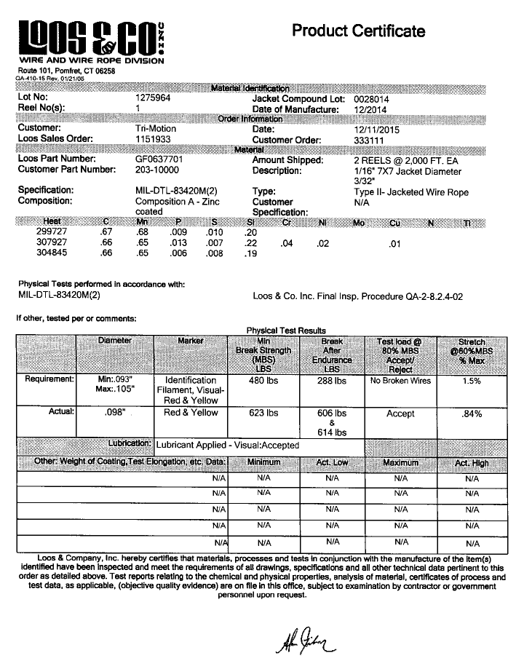
- Complimentary Declaration

