Importation invoicing instructions to comply with Mexican Customs Requirements
(In case of shipments coming from outside Mexico)

- Invoice / Proforma invoice / Customs invoice date

- Invoice / Proforma invoice / Customs invoice number

- Ship to (consignee): Please add the right company details depending on the received purchase order or LEGO request. Is required to type all information in the exact same way that is written, gray sections are only reference and musn’t be considered

Kind of company | Production site | Facilities owner and MAF production | To be defined
Company name: | LEGO OPERACIONES DE MEXICO, S.A. DE C.V. | LEGO REAL ESTATE, SA DE CV | ADMINISTRACIÓN DE SERVICIOS LEGO, S. DE R.L. DE C.V.
Company address: | Boulevard Nexxus ADN 2400  Parque Industrial Nexxus ADN  Cienega De Flores, N.L.  65580, Mexico | Boulevard Nexxus ADN 2400  Parque Industrial Nexxus ADN  Cienega De Flores, N.L.  65580, Mexico | Paseo Alexander Von Humboldt 43 A Torre II, PB Lomas Verdes 3A Seccion  Naucalpan de Juarez, Mexico, 53125, Mexico
Tax Id: | LOM080618AJ8 | LRE090701V37 | ASL021216V40
Kind of company | Sales office | Employee shop | Fundation
Company name: | LEGO MEXICO, S.A. DE C.V. | LEGO MEXICO, S.A. DE C.V. | LEGO FUNDACION MEXICO, AC
Company address: | Alexander Von Humboldt 43-A Torre II, PB Lomas Verdes 3A Seccion  Naucalpan de Juarez, Mexico, 53125, Mexico | Alexander Von Humboldt 43-A Torre II, PB Lomas Verdes 3A Seccion  Naucalpan de Juarez, Mexico, 53125, Mexico | Boulevard Nexxus ADN 2400  Parque Industrial Nexxus ADN  Cienega De Flores, N.L.  65580, Mexico
Tax Id: | LME941108ER4 | LME941108ER4 | LMF110325FW4

- Bill to: (according to purchasing previous instructions)
- Payer name
- Payer address
- Payer Tax Id (or VAT number)
- If free of charge, specify it is free of charge

- Supplier:
- Supplier’s name
- Supplier’s address
- Supplier Tax Id, VAT number, USCI or OC number. Is the record that companies has in their own countries usually with Fiscal Authorities

- Invoice content:
- Purchase order and line number (PO). (In case of shipping samples or warranty equipment, specify this condition.)
- LEGO Item number for material, brand, model, and serial number are required when shipping machinery or equipment. For molds, invoice must contain mold number. For an extensive list of equipment, use packing list for adding brand, model and serial number.
- Description
- Quantity
- Unit of measure (Example: pieces, set)
- Price per unit (specify currency)
- Total price
- Net weight
- Gross weight
- Country of origin
- Total pallets or bults
- Terms (INCOTERM) **
- Comodity code (HTS Code)

** INCOTERMS: It is important to receive in invoice cost information regarding transportation, insurance, and other services, according to agreed incoterm in purchase order:
FCA: Since LEGO is responsible for transportation and insurance, we DON´T expect to receive any cost related to transportation in the invoice.
DAP: It is necesary to mention in the invoice local costs, meaning cost of freight, insurance or any other service paid from Mexican Custom to the LEGO entity in Mexico. This information needs to be declared by concept in the invoice.Please see the next example:
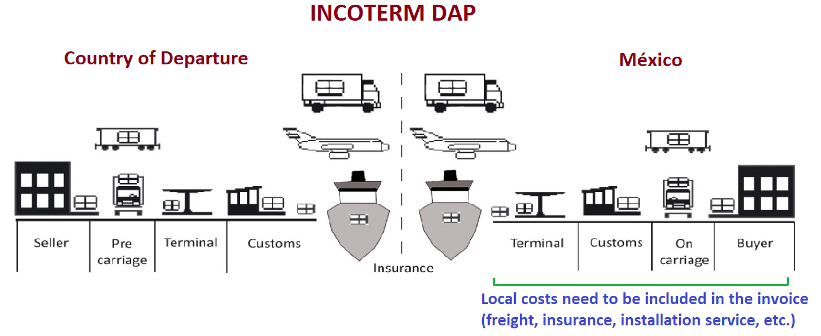

- Transport reference
For air shipments add Air Way Bill number.
In case of ocean shipments add container number or bill of lading number, vessel and ETA Mexican harbor

- Languaje
Invoices must be written in English, French, or Spanish

- Origin declaration note
If your company is approved by Authorities in Europe to certify invoices then state as follows:
If the goods have origin from the European Union and are shipped from within the EU, please declare the official note for this:
Example: “This exporter of the products covered by this document (Custom Authorization No.______) declares that, exept where otherwise clearly indicated…”

If your company is not approved by Authorities in Europe to certify invoices then: you still can certify invoices when the shipment value maximum 6000 EUR with the following text:
“The exporter og the products covered by this document declares that, except where other-wise clearly indicated, these products are from ________ preferential original of the generalized system of preference of the EUROPEAN COMMUNITY.” See next example:

- Returnable package items
If the shipment is comprised of returnable package such as plastic pallets or p-boxes, they must be declared on the invoice. If this is not possible due to regulation in the shipper country, an ‘’extra’’ proforma invoice must be sent for customs purposes.

- Extra information
Includes all the data that allows the shipper to accomplish with its country laws and regulations.

- Other type of invoices
- There are some other type of documents that we can use for importing goods and are also valid: invoice, proforma invoice, commercial invoice or invoice for customs purposes.
- Goods in warranty doesn’t require an invoice by itself, but at least a proforma invoice for customs purposes and a market value of goods needs to be declared to be used as base to calculate duties

