User guide
Planning of deliveries in the WTP application (instructions for supplier)

Contents
Contents 1
1. Validity of user manual 2
1.1 Purpose 2
1.2 Scope 2
2. Terms and abbreviations 2
3. Unloading (Inbound) 2
3.1 Editing of unloading 2
3.2 Extra Booking 3
4. Tips & Tricks 4

Validity of user manual

Purpose
The purpose of this manual is to familiarize the user with the method of working with the LEGO WTP application, which is designed for visualization of deliveries and parking at the LEGO facility in Kladno.

Scope
The scope of this manual is limited to procedures assigned in the application by the company of the (supplier / shipper). In particular it concerns tasks associated with entering the unloading of a delivery.

Terms and abbreviations
- WTP – Web Transport Planner
- Unloading (Inbound) – Import
- SPZ – License plate number
- AWB – Air waybill
- ETA - Estimated Time of Arrival
- ASN - Advance Shipping Notice
- CMR - International waybill
- LEGO Shipping - Department responsible for movement of vehicles with goods (import/ export)

Unloading (Inbound)
After logging in, the company representative accesses the main section for entering a delivery unloading.
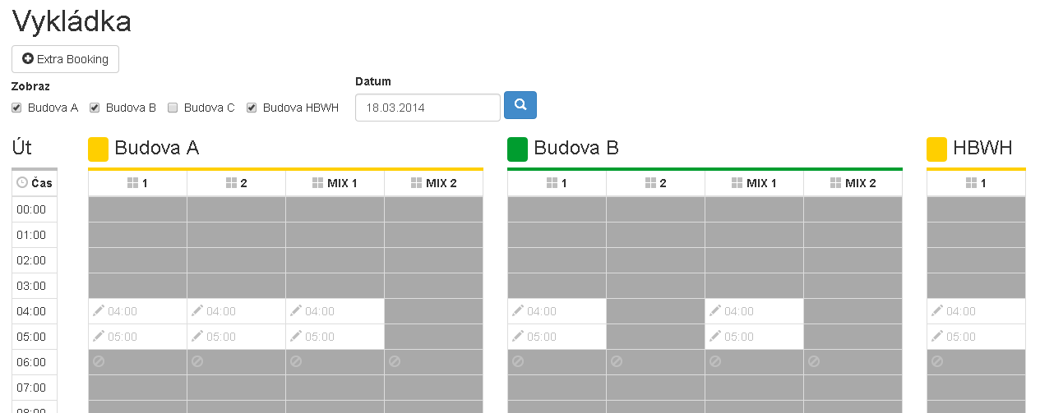

Editing of unloading
In the preview, available unloading windows are displayed for the user landing window, and within which he can enter the planned unloading. By clicking the field with the pencil icon, a form comes up for the user to enter a delivery unloading time.
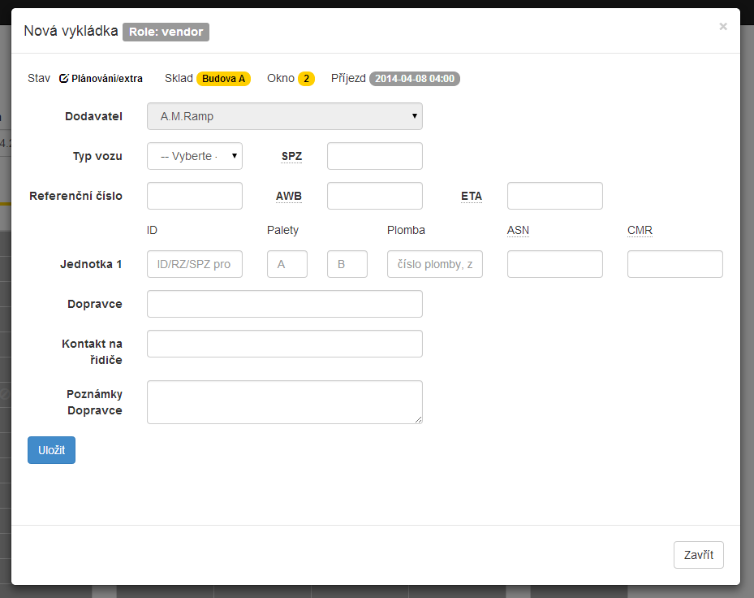
- Vehicle type
- Vehicle license plate number
- Reference number
- AWB – Air waybill
- ETA - Estimated Time of Arrival
- Identification of unit(s) – ID, number of pallets, Seal Number, ASN (Advance Shipping Notice) and CMR (International waybill)
- Shipper
- Driver contact
- Additional comments regarding unloading

Extra Booking
Also available is the “Extra booking” button, which enables simply requesting assignment of an extra unloading window. Information entered on the form is sent to employees of LEGO Shipping after the form is completed.
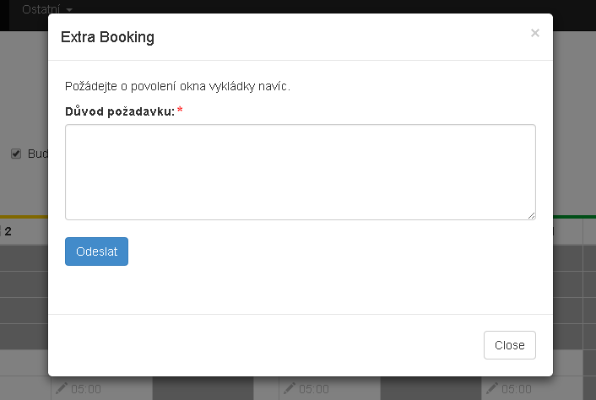

Tips & Tricks
How do I enter unloading of a delivery?
- In the unloading overview - https://kla.legowtp.com/cz/vykladka I select an available time period (white field with a pencil icon)
- On the form displayed, fill in the information relating to the given shipment loading
  - Vehicle type
  - Vehicle license plate number
  - Reference number
  - AWB – Air waybill
  - ETA - Estimated Time of Arrival
  - Identification of unit(s) – ID, number of pallets, Seal Number, ASN (Advance Shipping Notice) and CMR (International waybill)
  - Shipper
  - Driver contact
  - Additional comments regarding unloading
- After clicking on the “Save” button, the item is copied into the display of planned unloading

Until when is it possible to modify planned unloading?
- The system closes the scheduled landing at 14h of day preceding the day on which the landing is scheduled (On Friday, the plan closes for the entire weekend and the following Monday)
- After system closing, you will receive a summary e-mail with planned unloading times
- After this closing, you can only add potential comments to the unloading up until the arrival of the vehicle at the LEGO gate.
How do I request an additional unloading window?
- In the unloading overview - https://kla.legowtp.com/cz/vykladka the “Extra booking” button is available
- After clicking on it, a form will be displayed with the possibility of simply filling in the reason for requesting an additional unloading window.
- After clicking on the “Send” button, this request is sent to the LEGO Shipping department, where the request is evaluated

